**Assignment 24.2**

1. **Fetch date and temperature from temperature_data where zip code is greater than 300000 and less than 399999.**

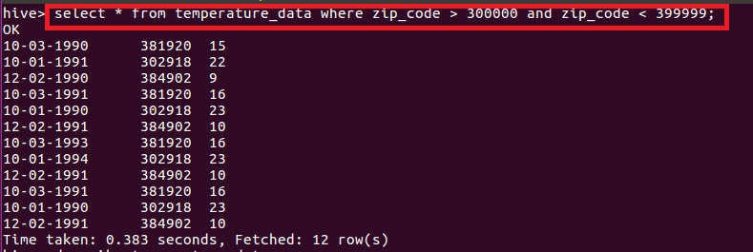

1. **Calculate maximum temperature corresponding to every year from temperature_data table. Select year from date by using substring function and gave alias name as Year and used max function to find maximum temperature and gave alias name as maximum_temperature and grouped by year.**

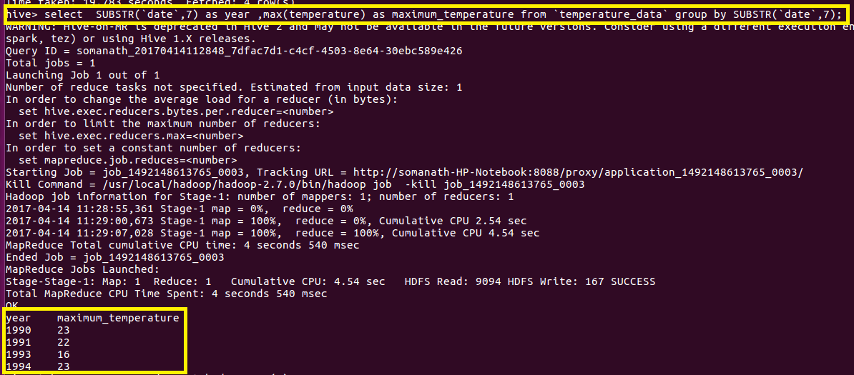

1. **Calculate maximum temperature from temperature_data table corresponding to those years which have at least 2 entries in the table. Select year from date by using substring function and gave alias name as Year and used max function to find maximum temperature and gave alias name as maximum_temperature and grouped by year. Filter by entries greater than 2 by using count in having clause.**

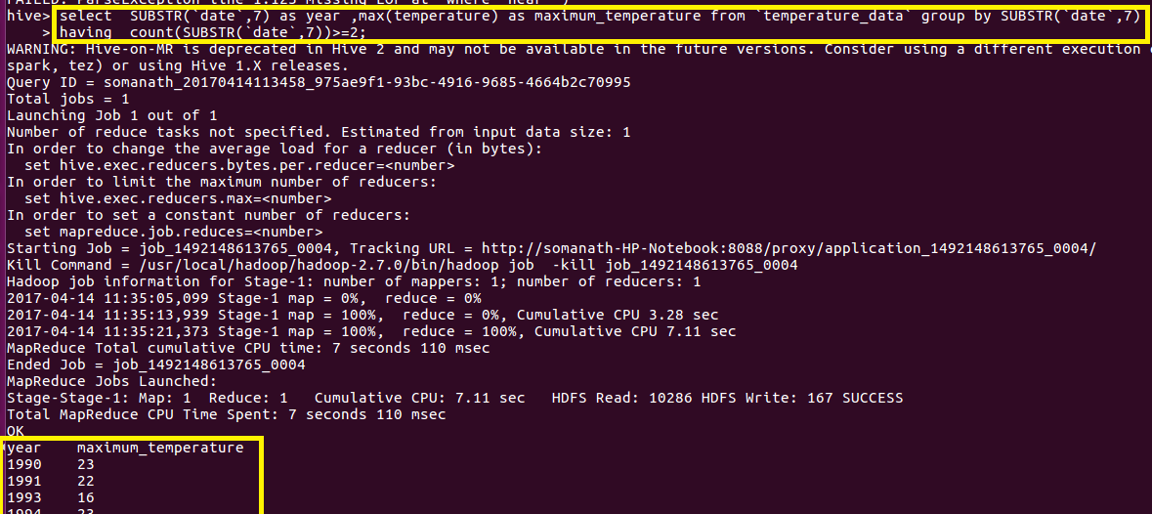

1. **Create a view on the top of last query, name it temperature_data_vw. Used create view to create view on last query and displayed the data of view to check the output.**

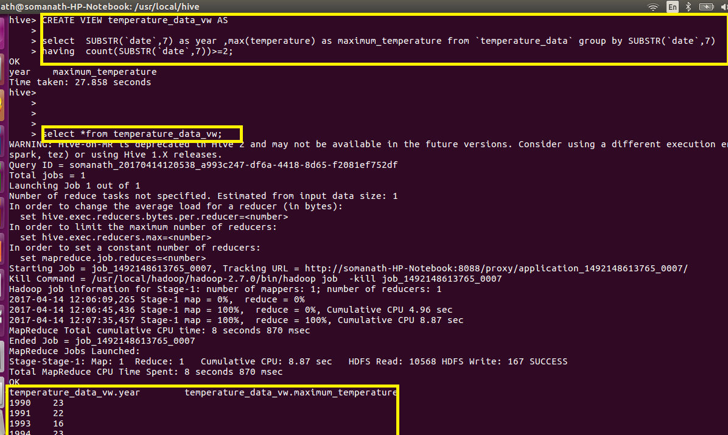

1. **Export contents from temperature_data_vw to a file in local file system, such that each file is '|' delimited. Used insert overwrite local directory to export contents.**

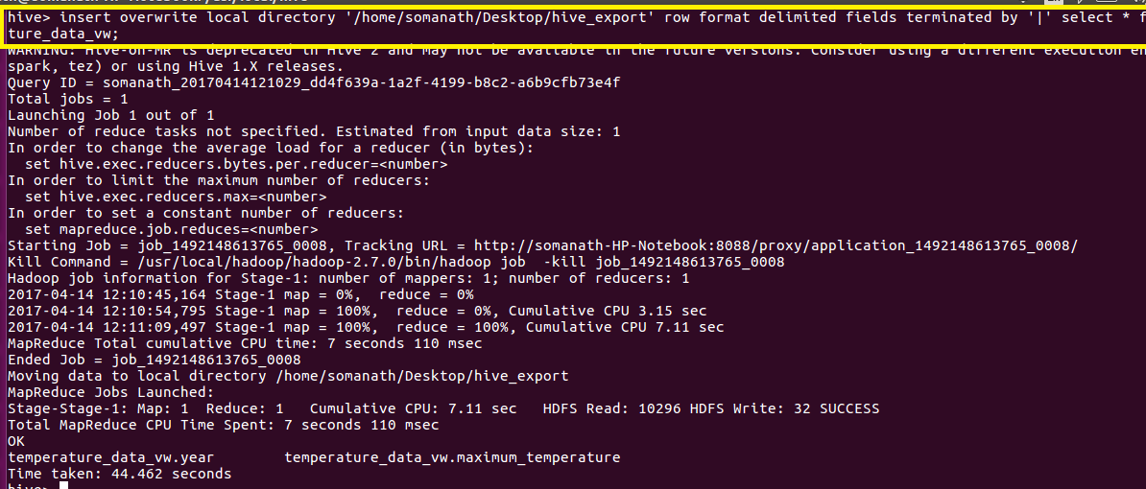

**Verification: The output delimited by | is written in hive_export**

